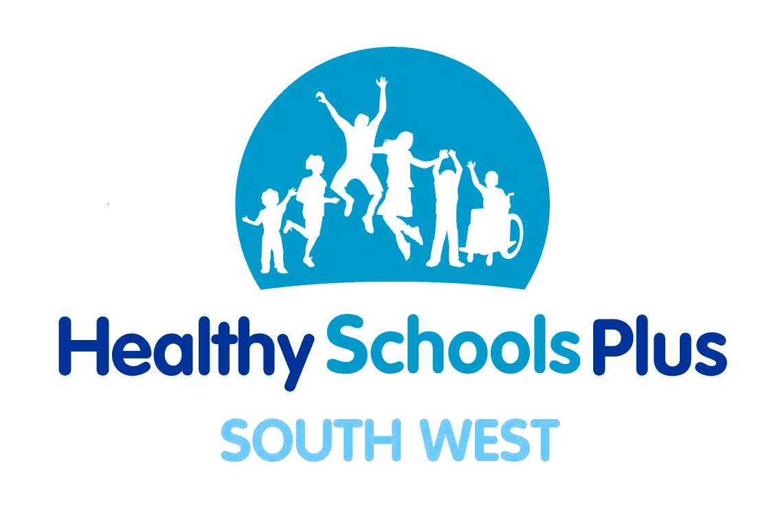

6 Month Progress Report

School: |  |  | Date:
Completed by:
Local Priority: Healthy Weight
Outcomes | Process | Impact
- To increase the number of children who...

- To increase the number of children who...

School Priority:
Outcomes | Process | Impact
- To increase the number of children who...

- To increase the number of children who...

CinCC:
Outcomes | Process | Impact
- To increase the number of children who...

- To increase the number of children who...

Other comments:

For example:
- If any of the outcomes set have been met
- If outcomes have been met, what new outcomes you would like to achieve
- What the next steps are for your school
- Details of HS+ funding and how this has been spent
- Particular successes

